C121 Readings & Assignments: Week 2

Week 2 Reading
Complete reading Week 2 lectures early in the week.
Textbook pages 84-101
Week 2 Assignments Overview
Assignment Summary: | Due Date
Assignment 1: Master Project Part 2: Proportions and Emotions in the Self Portrait and Character Model Sheets | Tuesday, April 14, 2009
Assignment 2: Observation Sketches | Sunday, April 19, 2009
Assignment 3: Master Project Part 3: Character Model Sheets with Gestures and Lateral Head Turns | Thursday, April 16, 2009 to Saturday, April 18, 2009
Assignment 4: Working Ahead | Week 6
Remember that all assignment details can be found on the assignment pages located throughout the week. Go to those specific pages for direction on how to complete each individual assignment.

Week 2 Overview
How did the self-portrait model sheets you created last week turn out? Did you follow any rules to create them? Or did you simply put down your visual images on paper? This week you'll learn some basic rules to help you create well-balanced characters for model sheets.
This week we'll focus on refining model sheets by introducing proportions and weight in character sketches. In addition to human proportions you'll learn about animal and cartoon proportions and how to add details such as emotions, gestures, and lateral head turns to model sheet sketches.
The assignments for this week include parts 2 and 3 of the Master Project and two job aids. The lessons and activities of this week will help improve your character-sketching skills.

Learning Outcomes:
• Generate well composed model sheets; both humanesque & animal characters
• Learn to exaggerate both animate & inanimate objects

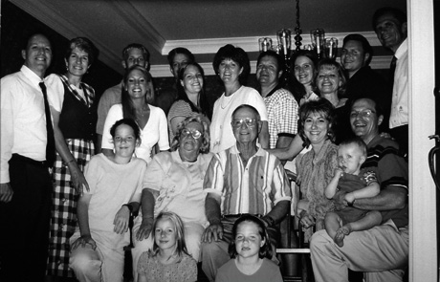
Human Proportions
When you look at people or animals, how are you able to distinguish a man from a woman or a dog from a cat? How can you distinguish between the silhouettes of a man, a woman, a child, a dog, a pup, a cow, a horse, or an elephant? There are some basic distinguishing factors for each of these categories such as the sizes and shapes of the head, the shoulders, the body, and the limbs. For example a man's shoulders are generally broader than a woman's shoulders.
These basic distinguishing factors are referred to as proportions. Proportions define the relative sizes of different shapes. These shapes can be of inanimate objects, of lines on a paper, or of parts of a human or an animal body. The basic proportions of the body of a cat are very different from those of a goat or a giraffe.
As an exercise you can study a group photograph of your family or friends where the age and gender vary from infants and teenagers (boys and girls) to adults in the age group of 20-35 and 60-80 (men and women). It is better to look at a single photograph that has a wide range because you can study them within the same point of reference. Look at the group photograph shown. Can you identify some basic proportions?
Generally, the ratio of the head to the body of an average adult human ranges from 1:7 to 1:9. 1:7 is the ratio for thinly built people, 1:8 for a well-built person, and 1:9 for a superhuman character.
For children, this ratio varies from 1:3 in infants, 1:4 in 7-8 year olds, 1:5 in 13-15 year olds, and 1:7 as they approach adulthood.
Using these proportions you can create a well-proportioned outline of a human. Creating sketches can be made simpler by using a grid as a guideline. This grid can have eight rows of height 1 inch each and five to six columns whose width measures about 7/8th of an inch. This grid will help you understand the relative proportions of the adult human character. Before proceeding to use this grid, you need to understand some basic body proportions.

Basic Proportions
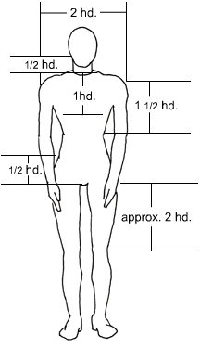
Generally the following proportions need to be considered while creating the human figure:
- Width of the shoulders is twice that of the head
- Height of the neck is 1/3rd or ½ of the head
- The torso, or body, is slightly V-shaped with its upper edge at the shoulders and the lower edge at the pelvis. The torso is double the height of the head and narrower than the shoulders at the pelvis
- The hip joints are about ½ the height of the head and as wide as the pelvis
- The length of the thigh and lower leg is approximately the same and is a bit less than twice the height of the head
- The elbow position is the same as the upper edge of the pelvis
- The fingertips are slightly above the knee
- The shoulder-ribcage base distance is approximately 1.5 head length
- The shoulder-sternum distance is around 1 head length
- The position of the navel is midway between the sternum and the upper pelvis
Based on these basic proportions you can draw a rough sketch of the human figure on the grid.
You can also study proportions by drawing a similar grid on a photograph of an erect figure. You will need to take the upper edge of the grid as the upper edge of the figure's head and the lower edge as the feet. Then, divide the grid into rows that are the height of the figure's head. The number of rows will vary between 7-9 for an average sized adult.

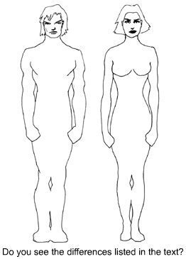
Masculine Features vs. Feminine Features
The muscular mass and skeletal system varies according to gender and age. For example men have straighter and squarer bodies than women, who are curvier. While the general shape of the male torso resembles the letter V, that of the females resembles the figure 8. As a result the center of gravity for men is at the shoulders while for women it is at the pelvis. The following table lists a few more differences. Based on your observations you can add other differences and use the table while creating characters.
Part of the body | Masculine features | Feminine features
Head and face | Heavy, broad, shaven/unshaven texture, very sparse eye lashes, thick eyebrows, firm jaw | Light, slim, curvy lips, longer eye lashes, thinner and neater eyebrows, bigger eyes
Neck | Broad and not very long | Thin and long
Shoulders | Broad and muscular, might be more than double the head width | Delicately built, around 1.5 times the head width
Chest | Muscular/straight | Full and rounded
Rib Cage | Muscular and broad | Delicate, small, narrow at the waist
Hips and Pelvis | Narrow and small | Broad and full
Hands | Large, square shaped, and broad with square nails | Smaller, around 3/5th of the male hand, soft textured, thin, tapering nails
Legs | Muscular/straight and strong with prominent muscles | Thin, delicate, curvy, tapering at the ankles
Feet | Large and broad | Thin and narrow, around 4/5th the male feet
A detailed observation of people and human anatomy is important to help you create life-like curves and shapes of the human figure. You can search for sites on the Internet about human anatomy and human figure drawing to study about the skeletal and muscular systems and their depiction through sketches.

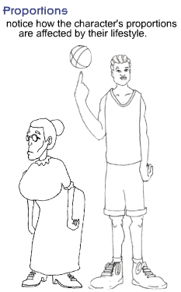
Adding Weight and Character
Although the basic features and proportions for humans can be classified as masculine and feminine, they vary from person to person and can help define the personality. The muscular build of a female fashion model will be very different from that of a female weight lifter. The relative sizes of limbs and torso to the head appear to be very different for thin versus heavy people. A thinly built man will appear to have longer hands and neck than a heavy person. This happens because the accumulation of fat on a part of the body increases its width making the body part appear broad and short.
The muscle and fat of a person largely depends on the person's profession, activities, lifestyle, and nature. For example a boxer may appear very different from a potter. There are differences because of the over or under usage of different parts of the body for various activities. The leg muscles of an athlete may be more prominent and well built than those of an artist. An artist will probably have long tapering fingers. Similarly a dancer's body will tend to be sleeker than that of a TV addict. People with less physical activity tend to put on weight on their thighs, hips, upper and lower back, abdomen, upper arm, and neck. This may also vary according to gender. Men tend to put on weight around their abdomen and arms while women tend to accumulate fat at their hips, thighs, and much later at the abdomen.
These observations are obviously based entirely on stereotypes and generalizations. When 2d and 3d characters are generated in production, we generalize and draw upon notions that most people have about weight, height, and proportion.
After creating the basic outline of the character's body, you need to refer to the character biography and identify the character's lifestyle. Based on the lifestyle you can modify the weight or muscles of the various parts of the body.
Fat can be represented in character sketches in the form of bulky wavy lines that fold on to the part of the body below it. Muscles can be shown as smooth, rounded, and firm lines. By shading and adding small, supporting lines, you can give an impression of depth and roundness to a specific body part.
It's important to take gravity into consideration while sketching weight on characters. Folds increase in length with an increase in mass. The fold will always be towards the ground or base plane. The following graphic illustrates the depiction of fat and muscles in human sketches.

Animal Proportions
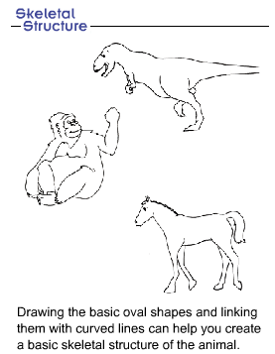
Like the human figure the animal figure also has some basic proportions. A good practice is to identify these proportions and represent them in the form of cylindrical or oval shapes. It would be impossible to discuss all animal proportions because there are more than 12,000 types of animals on this earth.
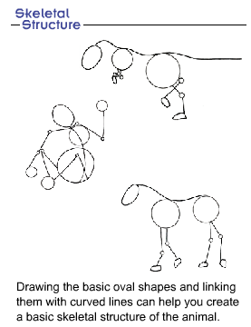
This week we'll cover a few basic proportions that can help you create various common animal figures. You need to have a keen sense of observation and interpretation to master the art of animal drawing. Look at an animal or its picture carefully. You should be able to identify the oval and spherical shapes of its body that clearly stand out. Drawing the basic oval shapes and linking them with curved lines can help you create a basic skeletal structure of the animal.
The different parts of the animal that define the structure of the animal figure are:
- Spine
- Ribcage
- Forelegs
- Elbow
- Paws
- Hind legs
- Tail
- Ears
- Mouth and nose

Spine
The skeletal structure of the backbone or spine can be represented as a curved line that starts at the head and ends at the tip of the tail.

Ribcage and Forelegs
The bulkiest part of the animal body is its ribcage. You can draw it as an oval shape that protrudes a little in the front of its legs. The size of the rib cage is generally greater than half of the total body size. So the center of gravity for an animal is at its chest. As a result the forelegs are stronger, shorter, and straighter than the hind legs as they need to support and carry the maximum weight.

Elbow
The forelegs are joined to the ribcage at the elbow. The position of the elbow with respect to the ribcage varies according to the height of the animal. For example the elbow is next to the ribcage in dogs and wolves while it is far below in giraffes.

Paws
The legs end at the paws, which are shorter versions of the human feet. Paws are also divided into toes with nails. The shape and size of the paw depends on the size of the animal and its lifestyle. For example the paws of a lion are much bigger and wider than those of a cat. An elephant's foot is much broader to support its weight, and the paw is not at an angle to the leg. A monkey's hand or foot has longer fingers with a well-defined thumb that helps it hold on to branches of trees.

Hind Legs
The hind legs of agile animals are more muscular and angular than the forelegs. The muscles imply the level of dependency on the body part, and the angle implies the springiness or potential force that can be provided. For an animal like a jaguar, which is fast and agile, the hind leg muscles and the angle at the rear knee joint are very well defined. But for an animal like the goat that does not run fast, the angle and muscles are comparatively less prominent. Instead its paws, or hoofs, are strong and hard that support the goat's lifestyle of mountain climbing and passing through rough and narrow rocky paths.

Tail
Although not all animals have tails, it is one of the most unique features in some animals. The shape and size of the tail again depends upon its usage. A cow's tail is thin and long with long hair at the end. This is used to swish away the flies from its back. Although a monkey's tail is thin, it's used like an extra limb to hang from trees because of being strong and long.

Ears
Animal ears are yet another unique feature. Like other body parts the level to which they are developed depends upon the usage and function of the ears in the animals' life. Many animals have movable ears. This is to help them focus on sounds coming from a particular direction without turning the entire head or body. Because the neck movement of an animal is more restricted than that of a human, the ability to move the ears is very important. The size and shape of the ears also varies according to the characteristics of the animal. An elephant's ears function as both auditory instruments and as fans to drive away flies and insects from the face. The lion's ears are small and rounded like a cup that helps in creating a louder vibration of the smallest sounds.

Mouth and Nose
The mouth and nose varies the most in animals. While an elephant's nose is long and can also serve as an extra limb, that of a cat or a dog is like a snout to sniff things quickly. Most animals have a snout that varies in length and breadth according to what they eat or how they hunt.
Basically, all parts of the human or animal figure have been created to serve a purpose or perform a function. Based on the purpose, you can identify the muscles or bones associated with the parts that are over or under-used. The parts that are used the most tend to get well defined and modified further. Parts that are not used tend to become smaller and weaker.

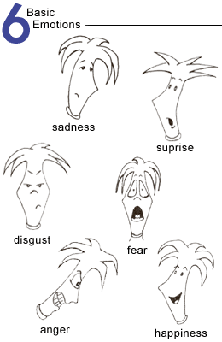
Creating Emotion
If someone were to say to you something that would make you happy, afraid, enraged or embarrassed your feelings would be transferred to the expression on your face. If you were to look at yourself in the mirror when you heard those comments that created your emotions, you would readily see them. Emotions are reactions triggered off as the result of an event or a situation or as an answer to the question, "How do you feel?" Think of all the emotions you have felt. How many can you list?
The six basic types of emotions that humans experience are:
- Anger
- Surprise
- Sadness
- Happiness
- Disgust
- Fear
Other emotions include jealousy, sympathy, aggression, boredom, determination, disappointment, envy, indifference, misery, suspicion, interest, satisfaction, shock, horror, frustration, confidence, arrogance, and curiosity. The list however, is endless!
Emotions help us express and communicate our feelings to others. This communication can take place through various methods: facial emotions, body gestures, or vocal expressions. In this course you'll learn about expressing facial emotions and body gestures through art.
To understand how your face expresses emotions, look into the mirror. Keeping a small mirror next to your PC would be a good idea! Now read each emotion listed above individually and try to feel the emotion. Look at your face in the mirror. Observe how each part of your face contributes towards expressing a single emotion. You will notice that you hardly move just one part of your face for any one emotion.
You can also act out various emotions in front of the mirror and keep sketching them in a notebook. Against each sketch you can write the description of the expression. This library of facial expressions can be very useful while creating character expressions.
Several features of the face change their shape or positions to express emotions. They are:
- Eyebrows
- Eyes
- Nose
- Cheeks
- Mouth
- Teeth
When a person is surprised, the eyebrows are raised in an arch, the eyelids widen to reveal more of the eyeball, and the mouth opens into a small "Huh!" When a person is scheming or planning to take revenge, the lower eyelid gets raised to reveal less of the eyeball, nostrils flare up, and lips purse into a thin flat line. When a person becomes angry, we say they "lose their charm." The face may looks frightful: the eyes widen, the eyebrows darken, the brow creases, and the mouth appears to growl. When a person is happy, the whole face gets exuberant with happiness. All the lines on the face such as the lower eyelid, nose creases, and crow's feet appear to laugh.
Using various combinations of the same basic features you can depict different emotions. You can sketch a narrow mouth with frowning eyebrows to represent anger. However if the shape of the mouth changes to a grin with the eyebrows remaining the same, the overall effect can depict mischief. While sketching it's very important that the shape of the nose does not change, though there can be a slight expansion of the nostrils.
You can apply what you learned from this animation and the mirror exercise on several model sheet characters by creating their Close-Up model sheet.
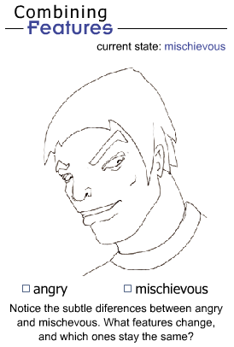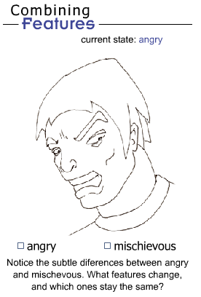

Drawing Gestures
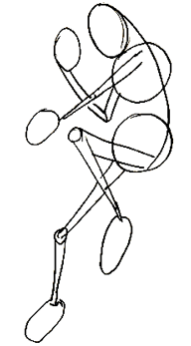
Gestures are one way of communicating emotions with the help of body movements. Observe the way in which you are sitting or standing right now. Are your hands on the keyboard, the mouse, the chin, the table, or your lap? How are your legs resting side-by-side or crossed? These are all gestures that communicate your present state of mind. For example if your legs are resting side-by-side, it implies that you are sitting relaxed. Crossed legs can indicate that the person is concentrating or focusing on something.
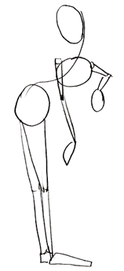
We use the term "Gesture Drawing" to connote the practice of creating quick sketches of a figure to represent the overall position, "energy," and direction the pose suggests.
Other gestures can include nodding, a wave of the hand bidding farewell, shaking hands, looking away, sticking the tongue out, expressing victory with fingers, or signaling thumbs up. Gestures can reflect your thoughts, words, or personality. For example standing with arms on the waist usually means being impatient, while fidgeting with the fingers while talking can indicate being nervous or scared.
Like verbal or written language, body language and gestures can differ from person to person and from place to place. A body gesture common in one country may not mean the same in another.
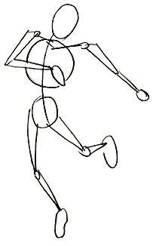
Gestures can be expressed using the head, the hands and arms, the pelvis, the backbone, and the legs and feet.
- Head: When held high, the head reflects confidence or snobbishness and when held low or drooping, it reflects tiredness or grief. A nod can communicate yes or no depending on the direction of the movement. When tilted at an angle and slightly upward, it indicates thinking. If the angle is towards the speaker, it indicates interest, if looking away, disinterest.
- Hands and arms: When the hands and arms are open and wide, they indicate openness and approachability. When they are closed, they signify aloofness, and when clutched tightly, nervousness or anticipation. The fingers can be used in various ways to communicate queries, consolation, command, anger, prayer, restriction, or victory. Hands are the most commonly used parts to express gestures.
- Pelvis: The angle at which the torso is resting on the pelvis indicates the concentration of the body weight on either of the legs. A person standing with the weight equally distributed on both legs could be listening attentively while standing with more weight on one of the legs seems to indicate being more at ease or careless.
- Backbone: Sitting or standing erect with a straight backbone signifies discipline and freshness in contrast to the slouched position that can mean being tired, lazy, or timid.
- Legs and feet: A person standing with legs wide apart may be considered rude or aggressive as compared to one who is disciplined and stands with his legs closed. Generally men tend to sit or stand with their legs apart, whereas women sit or stand with their legs closed. An outgoing, extrovert person's strides may be bigger and wider than those of an introvert.

Gestures can enhance communication. While some people are very expressive with their hands, others can be more expressive with their body posture. The effect of gestures can be understood by visualizing two children reciting poems. While one child is asked to use the hand and arms to express each word of the poem, the other is asked to keep the hands clasped throughout. The difference will be clearly visible. Gestures facilitate the communication process.
In addition there are several gestures that animals make to communicate their needs. The wag of a dog's tail indicates happiness and excitement while a broad and rapid swishing and lashing of a cat's tail indicates warning and anger. The way a dog or a cat nuzzles into your lap indicates the desire to play or be petted.
Representing gestures through art is closely associated with observation and an understanding of the basic human anatomy and movements. Observe and list the various gestures that you come across at the place of work, the home, a marketplace, on public transportation, or at a fast food restaurant. Attempt identifying what the gestures are possibly communicating. Then replicate the gestures through a sketch on paper. This will help you understand and create gesture drawings that are more life-like and real.

Lateral Head Turns
While creating model sheets and character sketches, you need to be careful in illustrating the lateral head turn or rotation of the head and body of a character in 2-dimensions. This is done in Character Rotation Model Sheets where the character needs to be shown in the front, back, side, and three-quarter views.
It's important to accurately depict lateral head turns while designing character sketches because they help visualize the 3D form of the character by illustrating its poses from various angles.
To create a 3D model of Marilyn Monroe, a Character Rotation sheet will be required. The front view will specify the position of the facial features. The side view will define the depth such as the pout of the lips, the depth and curvature of the nose, and the bulge of the forehead. The back view will illustrate the shape of the shoulders and the hairstyle. The three-quarter view will be a combination of all the other views and will portray the 3D form in 2 dimensions.
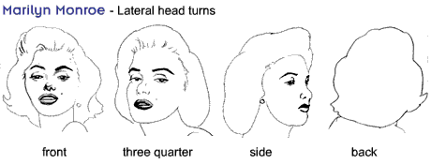

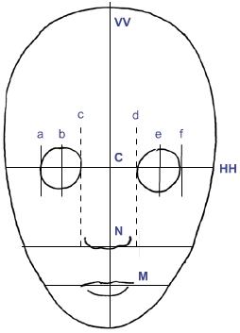
Front View
The front view is simple to create after you understand the basic proportions of the face and head. Try following the listed steps to create a character's front view sketch.
- Draw the basic shape of the face.
- Draw the guidelines.
- Identify the positions of the facial features.
- Draw rough sketches of the features.
- Refine the final sketch.
1. Drawing the Basic Shape of the Face
To create the front view of the face, create an egg-shaped oval with the narrow end facing down.
2. Drawing the Guidelines
Next you need to divide the oval into half, both horizontally and vertically by drawing straight lines with a light pencil across the oval. We shall refer to the lines as V V and HH and the point of intersection of the two lines as C.
3. Identifying the Positions of the Facial Features
The line HH defines the position of the eyes. Divide the line HH into eight segments marked by points a, b, c, d, e, and f. The segments ac and df define the width of the eye. Create light circles for eyeballs with diameters as ac and df and centers as b and e, respectively.
Divide the lower half of the vertical line, i.e. CV, into half and name the intersection point as N. This point defines the center of the nose. Divide the segment NV into half at a new point called M, which will define the center of the mouth.
4. Drawing Rough Sketches of the Features
Create rough light lines to depict the nose and mouth. The ears are usually the same size as the nose. Draw the ears.
To draw the eyebrows, join the base of the nostrils to the edges of the eye and extend it beyond the circles. Now join the protruding lines by using arcs to represent the eyebrows.
5. Refining the final sketch
You can refine the pencil sketches to complete the face, or front head, of the character. Similarly there are some steps and guidelines to draw the side profile.

Side Profile
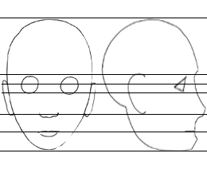
To draw a side profile proportionate to the front profile, you can have the front profile of the same character on the same model sheet as reference.
Extend the horizontal guidelines of the face across the model sheet. Using the uppermost and lowermost lines as extremes, draw another egg-shaped oval. It should be slightly distorted at one side. This defines the jaw line in the side profile.
Using the guidelines change the outline of the oval to reflect the forehead, eyebrows, nose, and tips as shown in the diagram.
Now define the nostrils, lips, and eyebrows. The eyes in the side profile will be half as broad as the actual eye in the front profile. In the side profile the shape of the eye resembles a wedge. The corner of the eye is marked with crow's feet lines.
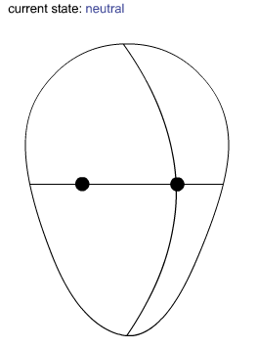
Next you need to sketch the ear. The ear's position is measured in terms of its distance from the eye. An important rule that you need to follow while drawing an ear is that the distance between the ear and eye in the side profile is usually the same as the distance between the eye and chin. Add finishing touches like hair and the shapes of the cheeks, and the side profile is complete.

Three-Quarter View
This view is called Three-Quarter because only 3/4th of the face of the character is visible to the viewer.
The basic head shape is represented as an egg-shaped oval. Here you need to look at the oval shape as 3-dimensional and not 2-dimensional. The narrow part of the oval should be at the base. Depending upon the tilt of the head you need to decide the angle of the oval. Then you can sketch the three-quarter view by following some basic steps.
- Draw a very light colored axis through the center of the oval shape.
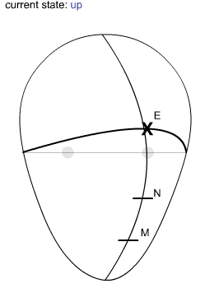
- Divide the horizontal axis into four parts identified by small round dots. Depending upon the direction in which the character needs to face, select the dot closest to that edge of the oval.
- Using the top and bottom points of the vertical axis as the end points, draw a curved line passing through the dot that you have selected. This line will define the vertical centerline of the face in three-quarter view.
- Similarly join the endpoints of the horizontal axis in a flat ellipse shape. The ellipse defines the horizontal centerline of the head and resembles the equator, which is an imaginary line around the horizontal perimeter of the earth.
Depending upon whether you want the head to look upwards or downwards, select the upper or lower curve of the ellipse as the front of the head. This line marks the position of the eyes and the start point for the nose. Mark the point where this line intersects the vertical curved centerline with an x. This point will be referred to as E. This will have to be the front most center point of the face.
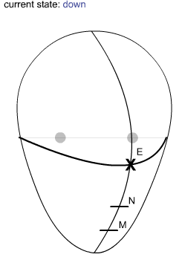
Divide the lower half of the vertical centerline into two by drawing a curved line parallel to the horizontal centerline. The point where the two lines intersect marks the lower edge of the nose, referred to as N. Divide the vertical centerline below the base of the nose into half again. This point, which shall be called M, defines the position of the mouth.
Using the points E, N, and M, draw the basic shapes of the eyes, nose, and mouth, respectively. While drawing three-quarter views, you need to be aware of the term foreshortening.
Foreshortening refers to the change in proportions with respect to the distance from the viewer. It causes objects/shapes that are further away to appear narrower and slightly shorter than the closer objects/shapes. As a result the further eye appears to be narrower than the nearer one.
Similarly the distance between the ends of the lips to the point M will be larger for the end that is closer to the viewer than the other end.
After incorporating all details you'll also need to define the shape of the cheek and eye that is further away to complete the 3D view. You can then refine the sketch to complete the character's head views of the front, side, and three-quarter.

Cartoons
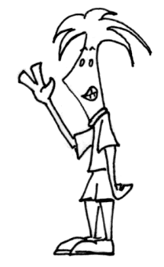
What is the first thought that comes to your mind when you think of cartoons? Smiles, fun, and humor? Adventure, mystery, and intrigue? All these emotions are generated through the use of exaggeration. Donald Duck's beak, Popeye's thinness and blown up arm muscles, and Johnny Bravo's hairstyle all convey a certain quality and help maintain the impression we have when viewing them.
Cartooning is a form of media where, using animation, characters are shown with simplified features, but still maintaining an ability to be recognized.
The basic elements in every cartoon character are:
- Identity or character
- Proportion
- Shape
- Expression
These elements can vary from character to character. For example Scooby Doo's body is made up of a flattened oval shape for his chest, dumbbell-shaped legs, and a thick long cylindrical neck. His proportions vary from a big chest, big nose, and big paws to small eyes, small ears, and thin legs. His character is that of a modest, loving, and nervous dog who is very faithful to his master and loves to eat. His facial expression is that of a lovable dumb character with a unique way of laughing.

Identity or Character
Before you begin cartooning a character you need to be clear about the character's personality. Based on the character design the character can be characterized cute and loving, evil, dominating, or scared. These traits help define the overall appearance and posture of the character.

Proportions
The type of character also influences the body proportions of the character. A boy-next-door type of character will have regular proportions. This implies that no one part of the body is out of proportion. Superman, Spiderman, and Phantom are superheroes and their design will tend to be a little lopsided towards perfection with an exaggeration of their shoulder and chest muscles. In addition they are well built, strong and muscular, and erect. In contrast all villainous characters are either too thin, stooping, with perhaps a disfigurement, or too muscular and pugnacious. This linking of certain characteristics to character types is called typecasting.
Listed below are a few character types and their proportions:
Character Type | Proportions
Heavy pugnacious (wrestler) | Small head, large chest or body, heavy arms and legs, protruding or heavy jaws and chin, pug-nose, beady eyes, heavy brows
Cute | Baby-like proportions, large head, oval body, high forehead, large eyes, small eye brows, small mouth/eye/chin area
Hero/sophisticated | Well-groomed hair, clean shaven, strong chin, straight nose
Loser | Pug nose, small and tired eyes, big ears, weak chin

Shapes
In contrast to human sketches detailing is not required in cartoon sketches. Cartoon sketches mainly convey exaggerated emotions through simple shapes and lines. The head can be represented as circular, oval, or rounded square. Eyes can be drawn as simple circles, ovals, dots, or lines. A single or double line for the lips, a curved line for the eyebrows, and a line, circle, oval, triangle, or dots for the nose can suffice.

Expressions
The body posture and the expression of the eyes define the attitude of a character. A drooping and tired body posture may define a lazy or beaten character whereas a bright eyed, erect, or dynamic posture such as that of Tin Tin defines an attentive or enthusiastic character.
While cartooning, after the basic image of the character is formed in the mind, it's a good practice to create several rough idea sketches that show the character in different poses or angles. These sketches need not be perfect or well balanced. They will only be a reflection of the basic idea that you can refer to while creating final sketches.

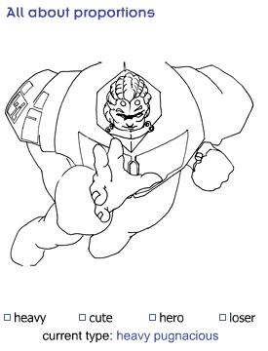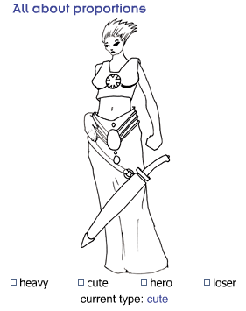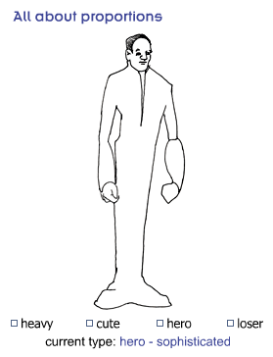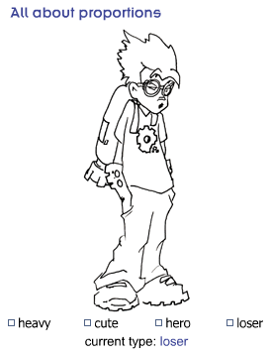

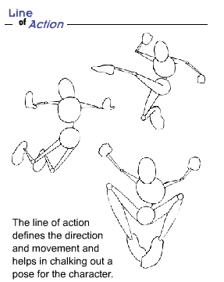
You can draw a cartoon sketch by following some basic steps:
- Create guidelines
- Draw the line of action
- Create the skeleton
- Draw the basic shapes
- Create the rest of the body and limbs
- Define the position of the head
- Add features to the face
- Create emotions and expressions
1. Creating guidelines
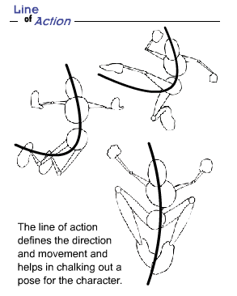
Refer to the rough idea sketches. Next draw the basic guidelines on your model sheet defining the sizes of the different parts of the body such as the head, torso, legs, and feet. This will ensure consistency of proportions in the different images of a character.
2. Drawing the line of action
The line of action defines the direction of movement and helps in chalking out a pose for the character. For example if a person bends down to pick up something from the ground, the line of action will be an invisible line running through his body joining the base of his feet to the tip of his hand. This person's line of action will be like an inverted U. A person with an axe in his hand who is about to strike a piece of wood will have the line of action in the shape of the letter C.
3. Creating the skeleton
The skeleton here does not refer to the actual skeletal system of the character. It refers to the basic lines that define and represent the line of action for all the parts of the body. The character will now look like a stick figure.
4. Drawing the basic shapes
Using the skeleton as the basic centerlines for each part of the body, create ovals and cylinders to represent the different masses of body parts. You can think of the head as a flexible oval balloon. The shape of the head can vary from a perfect round sphere, egg-shaped, to a horizontally flattened oval. The torso or body can either be a single oval or a combination of two ovals joined by lines at the waist.
5. Creating the rest of the body and limbs
Join the basic shapes with the help of simple lines to complete the character's figure and draw the hands and feet. The sizes of the hands and feet depend on the personality, age, and gender of the character. For example the female hand is thinner than the male hand. The hand of a child will be more pudgy and smaller than that of an adult. The number of fingers on each hand in cartoon characters can vary from 3 to 10.

6. Defining the position of the head
The position and angle of the head oval defines the emotion and attitude of the character. The following list explains some of the emotions that can be associated with different head angles. Based on your observations and study of human characters, you can add more such gestures and emotional expressions.
- Upward looking head: Hope
- Downward looking head: Dejection
- Bent forward head and protruding chin: Anger
- Bent forward head and stretched neck: Surprise
- Backward bent head: Alarm or laughter
7. Adding features to the face
After completing the basic shape of the character, you can focus on details such as facial features. Before drawing the features it's preferable to draw the facial guidelines. These help you identify the centerlines and points of the various facial features. The face and head consist of two types of features, movable and immovable. Movable features such as eyebrows, eyes, and mouth help in expressing emotions. Immovable features such as hair, ears, nose, and chin help in defining the personality and character.
The following table lists a few interpretations of the different facial features.
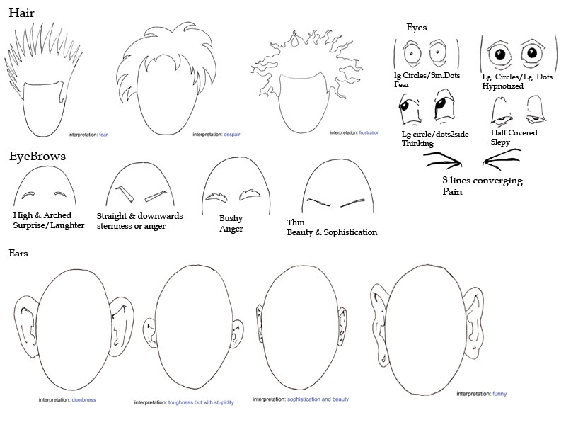

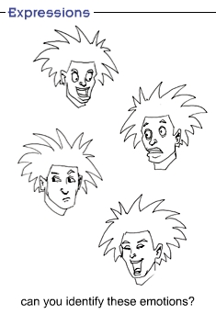
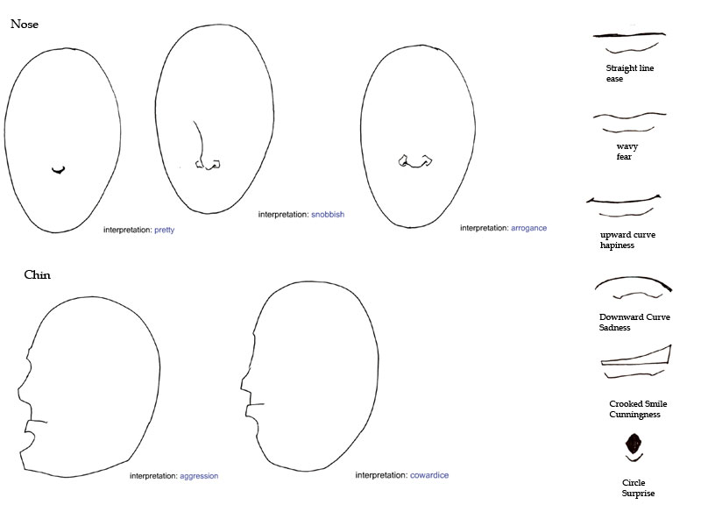
8. Creating emotions and expressions
Using different combinations of the facial features listed in the previous table, you can create various emotions and expressions. A few expressions are drawn for you.
Now pick up a pencil and paper and start experimenting with cartoons.
To start with you can draw cartoon sketches of people close to you, friends, and neighbors. Photographs will be useful in providing the basic guidelines. Identify the most striking feature in the photo and exaggerate it. Change the other features to simplify them and try creating happy, sad, naughty, evil, or aggressive cartoon sketches of these people.
Constant practice will improve your skill immensely.
Happy cartooning!

Summary
We express our feelings and emotions through facial expressions and gestures. As the characters that we develop need to show emotions and feelings, knowing how to depict them effectively is crucial to character development. This week's lectures covered adding details and refining characters to make them more believable. You learned to add emotions and gestures to character model sheets that transform mere drawings to well-balanced, complex, and original characters.
With this knowledge you can start developing well-proportioned character sketches and model sheets, detail them out, and make them more interesting by adding drama and character through the effective representation of:
- Emotions - by changing the shape and position of different features of the face
- Gestures - by changing the position of the head, hands, arms, pelvis, backbone, legs, and feet
- Lateral Head Turns - by ensuring consistency in the different views of character sketches - front view, side profile, and three-quarter view
Practice these concepts in the assignments before proceeding to the next week's lectures.

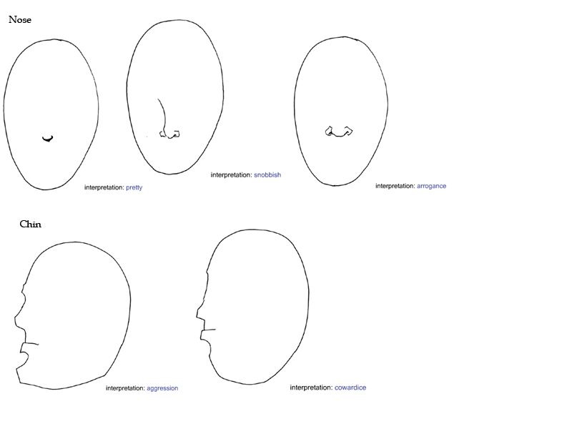
Assignment 1: Master Project Part 2: Proportions and Emotions in the Self Portrait and Character Model Sheets
This week you studied creating well-balanced character sketches and model sheets. You learned about human and animal proportions and character design variations based on gender, weight, emotions, and gestures.
In the light of these character design specifications:
- Review the sketches that you posted last week for flaws in proportions.
- Compare your sketches with this week's material to identify the areas where the proportions changed.
- Based on the knowledge you've gained this week, refine the sketches that you had created from the photographs. Do not trace photographs to create the sketch.
Referring to the descriptions of the game characters posted last week, create well-proportioned model sheets of the following game characters:
- One male character
- One female character
- One pet (male or female)
The model sheets of each character should consist of poses of that character in at least two of the following five moods:
- Angry
- Sad
- Jealous
- Happy
- Confused
By Tuesday, April 14, 2009, post the sketches and model sheets to the appropriate Discussion Area for review and discussion.
Review the sketches of at least two other students as early in the week as possible and:
- Comment on the accuracy of proportions. Discuss flaws, if any, and share any shortcuts that you know as well as other instructions or tips to ensure well-proportioned sketches.
- Discuss the depiction of emotions in the model sheets. Suggest methods/tips to effectively depict emotions.
Post your comments to the appropriate Discussion Area.
Assignment 1 Grading Criteria: | Maximum Points
Created well-proportioned sketches of the characters  (Proportions should be appropriate for male, female, and animal figures as discussed in the lectures.) | 4
Identified the areas where proportions were changed | 4
Suggested improvements for at least two students | 4
Depicted at least two of the following moods in the model sheets of the three characters:  - Angry  - Sad  - Jealous  - Happy  - Confused  Note: 4 points for each mood of each character | 24
Shared at least one learning or shortcut | 4
Arrived at well formed conclusions supported with valid reasons | 4
Discussions reflected the understanding of the content | 4
Provided are meaningful, clear, and concise responses | 4
Actively participated in class discussions and gave constructive feedback and comments for at least two responses posted by other participants | 4
Actively participated in the Problems and Solutions discussion forum. | 4
Total: | 60
For assistance with any problems you may have when completing this assignment—OR—to offer your assistance to classmates, please use the Problems and Solutions Discussion area located through the left side navigation link.
In animation, we have two types of model sheets that we include in the model pack to give to the animation team so that everyone draws our character the same way. One type of model sheet is describing specific look and measurements of the character. We usually provide a "turnaround" of the character from 4 or more angles. This gives everyone the same picture of exactly what our character looks like from all angles.
The second type of model sheet is what at the studios we call the "Poses and Expressions" sheets. These are sketches of our character in all sorts of poses and wearing all sorts of expressions.
Here are some examples of professional model sheets. Note the consistency of the characters. When you look at the character from any angle, they still look like the same character, not suddenly taller or thinner - consistent proportions! Also note that if you were to just look at the shadow of the character, you could still recognize it. In the beginning, I always see students draw characters who are of average height, weight and muscle. You couldn't recognize them in a line-up. Have more fun with your characters!
I have examples of model sheets on my blog:
www.studentsofanimation.blogspot.com
If anyone finds model sheet examples from games, please feel free to post link here or in the webliography! Thanks!
As for this assignment, draw three characters wearing at least two different emotions. LABEL the emotion, so we can see what your intention is.

Assignment 2: Observation Sketches
Continuous observation and sketching is the key to understanding movement in animation. Each week you will have a thread to post your sketches and comment on others. You will then have a chance to modify them before final submission in Week 6. By Sunday, April 19, 2009, create at least 6 sketches from observation of movement, gesture, and emotion.
Some suggestions to get you started thinking would be:
- Figure Walking
- Figure Running
- Figure Skipping
- Figure Jumping
- Hand Opening
- Hand making a Fist
- Animals and Pets
- Leaves Blowing in the Wind
- Baby Crying
- Child Laughing
- Child Playing
Be sure to turn in your sketches each week to get feedback. In Week 6 you will zip all your sketches and submit them with your Master Project. These sketches are worth 120 points in your Final Grade and will be added in to the total points of your Master Project.
Assignment 2 Grading Criteria: | Maximum Points
Observations Sketches | N/A  (Note: Grade for Observations Sketches will be incorporated into your Master Project)
Submit 6 sketches from observation per week
For assistance with any problems you may have when completing this assignment—OR—to offer your assistance to classmates, please use the Problems and Solutions Discussion area located through the left side navigation link.

Assignment 3: Master Project Part 3: Character Model Sheets with Gestures and Lateral Head Turns
Gestures help communicate emotions with the help of body movements. We usually express gestures by using the head, the hands and arms, the pelvis, the backbone, and the legs and feet. "Gesture Drawing" in model sheets refers to creating quick sketches of a figure to represent its overall position, "energy," and direction of movement.
Model sheets also help communicate the 3D views of a character through Character Rotation Model Sheets in which a character is shown in the front, back, side, and three-quarter views. These character rotation model sheets help visualize the 3D form of the character by illustrating its poses from various angles.
In this assignment you'll practice and learn how to depict gestures and lateral head turns in model sheets.
By Thursday, April 16, 2009:
- Study people around you and identify at least two common gestures from day-to-day life.
- Modify the model sheet of the male character, which you posted earlier this week, to depict two different gestures.
- Post the model sheet with a description of the gestures to the appropriate Discussion Area for analysis and discussion.
Use the female model sheet, which you posted earlier this week, to create another model sheet of the female character to show the following views:
- Front
- Side Profile
- Three-quarter View
- Back
By Saturday, April 18, 2009, respond to the discussion questions assigned to you by the facilitator. Submit your responses to the appropriate Discussion Area
By the end of the week, review the postings of at least two other students and discuss the depiction of gestures through sketches. Was the depiction of lateral head turns in the model sheet adequate? Discuss and suggest other options. Post your responses and feedback to the appropriate Discussion Area.
Assignment 3 Grading Criteria: | Maximum Points
Identified and incorporated at least two common gestures used in day-to-day life in the model sheet of the male character  (Note: Even if the level of detail is not high, marks can be allotted if the sketches are accurately able to convey the communication.) | 8
The gestures depicted in the sketches matched their description | 4
The model sheet had the following views of the female character:  - Front  - Side Profile  - Three-quarter View  - Back | 16
Maintained proportions of the female character in the various rotation poses of the character rotation sheet | 4
Arrived at well formed conclusions supported with valid reasons | 4
Discussions reflected the understanding of the content | 4
Provided are meaningful, clear, and concise responses | 4
Actively participated in class discussions and gave constructive feedback and comments for at least two responses posted by other participants | 4
Actively participated in the Problems and Solutions discussion forum. | 4
Total: | 52
For assistance with any problems you may have when completing this assignment—OR—to offer your assistance to classmates, please use the Problems and Solutions Discussion area located through the left side navigation link.
Post your images here and discuss the following questions together. You must respond to at least two of your classmates:
What are the various ways in which people perform gestures to communicate without using hands?
How does the incorporation of gestures into animations and character sketches affect the final output?
What types of animation (games, fantasy movies, science fiction movies, advertisements, cartoons, etc.) can benefit from the incorporation of gestures and emotions? Which of them would be most effective, and how?

Give us at least 3 posts here and try to ask a lingering question for your classmate's to respond to. Cite examples/links whenever possible.

Post your images here and discuss the following questions together. You must respond to at least two of your classmates:
What are the various ways in which people perform gestures to communicate without using hands?
How does the incorporation of gestures into animations and character sketches affect the final output?
What types of animation (games, fantasy movies, science fiction movies, advertisements, cartoons, etc.) can benefit from the incorporation of gestures and emotions? Which of them would be most effective, and how?

